University of North Alabama

INTRODUCTION TO APA STYLE

Center for
WRITING EXCELLENCE

Cayla Buttram
David MacMillan III
Dr. Robert T. Koch Jr.

January 2013

Contents
Elements of Good Research & Writing 3
Formal Research Model (Inset Box) 3
What does APA Mean? 3
APA Layout Overview (Inset Box) 4
Creating a reference page 4
In-text citation 5
Source integration 5
Block quoting (and example) 6
Signal phrases 6
Examples 6
Organizing information 7
Headings 7
Bullets and numbering 8
Tables 8
Contributors 8
Formatting examples 9
Title page and abstract 9
Body pages and reference page 10
References 11

Introduction to APA Style
The American Psychological Association has set the standard for communication in the medical and social sciences since 1929. This guide is based primarily on the Publication Manual of the APA, Sixth Edition © 2010.

Elements of Good Research and Writing
Each paragraph or section of a research paper needs to have three distinct parts: claim, evidence, and discussion. The claim is the paragraph or section’s main idea, and it refers back to the thesis (the main idea of your paper). Evidence is the information you find in your research that supports your claim. Last, the discussion explains how the evidence given is relevant to the claim.
Organizing Formal Research Papers
If you are writing a formal research paper, the following elements are usually used.

Introduction
Introduce the research question and explain the background of the issue you are researching.

Review of Literature
Synthesize background research on the topic.

Methodology
Explain your experiment/research process.

Findings
Provide the data produced by your research.

Discussion
Explain the implications of your findings along with your research conclusions.
Simply presenting the evidence is never enough. Always explain how the source can be used to support the claim as well as how it helps develop the overall purpose of the paper. It is better to have one or two sources that are thoroughly explained than to have three or four sources that have no context or explanation.
When using primary research, such as interviews or surveys, the research methods also need to be explained. However, when evidence consists of secondary sources, such as a journal or book, you rely on the citation information to explain why each source is useful.
What does APA Mean?
Formal research projects include specific content sections, briefly explained in the box above. However, not all APA papers are formal research projects, so your paper might not include all of these sections. (Ask your professor or check your assignment sheet.)
An “APA paper” refers to the formatting of content, not necessarily the content itself. This formatting dictates the specifics of elements such as the title page, abstract, in-text citations, and reference page. The use of a specific format allows the reader of your paper to quickly identify the information they need, such as how and where information was obtained. APA is intended primarily for use in the sciences.
The most important piece of information for APA citation is the date; in APA, newer knowledge is almost always preferred. Examples of APA format can be found on pages 9 and 10. The text in this document describes the elements pictured in these examples, as needed for an APA paper.
When you start researching and writing, remember that an important goal is keeping track of information sources and how they are relevant to the topic and argument. Introducing sources in a paper and identifying how they support claims are just as important as the technical aspects of the citation itself.
Creating a Reference Page
APA Layout Overview
Title page
Provides the author’s name, the title, the running head (short title), and the university affiliation. May contain additional information in an author note (see page 9).

Abstract
Header matches the body pages, not the title page. Includes a concise and non-evaluative summary of the research project, describing the problem, the method of study, the basic findings, and the implications in only a paragraph! See page 9.

Body pages
Starts with the full title centered on the first page. 12 point, Times New Roman font, one-inch margins, indented double-spaced paragraphs (see page 10).

Reference page
Starts with “References” centered at the top of a new page. Uses hanging indent to separate individual references (see page 10).
All the sources specifically mentioned in your paper must appear, alphabetized, on your reference page (certain exceptions exist for interviews, extremely common sources such as scripture, and personal communication; see the APA Manual). If your professor asks you to include a bibliography of sources you read but did not reference, this is also where they go.
If Microsoft Word’s “References” tab is used, be sure to check the final product against a style guide. Automatic formatting or citation machines are often incorrect.
The point of citing sources is to provide the necessary information for the audience to be able to identify, assess, and locate sources. Include as much information about the source as possible. Correct formatting helps your reader quickly understand the information.
APA references follow this pattern: Who. (When). What. Where.
Who. Identify the author, authors, or editors of a document. If a given document is produced by a corporate author, then the name of that entity may be used. The name of a website, however, should not be used here; it is part of Where, along with the page URL.
(When). Placing the latest date of publication in parentheses after the author indicates how recent the information is. The year of publication is usually sufficient; however, some source documentation formats require a more precise date. It can be included in the following format: (2008, September 30) or (2008, September). If there is no date, it is all right to use (n.d.) to indicate this. Sometimes, though, sources without a date may not be reliable.
What. This identifies the title of the article, book, webpage, film, project, section, or chapter. Only the first word and any proper nouns (plus the first word of the subtitle) should be capitalized, regardless of how the capitalization looked in the original title. Titles of major works, like books and films, should be italicized; titles published within a larger work are not italicized. Citations of a specific chapter in a book include the chapter title and the book title with only the book title italicized. If the source is an editorial, monograph, special section, diagram, or other uncommon source, indicate this at the end of the title using [brackets].
Where. This provides the reader with instructions on how to find the What. The type of information listed here depends on what type of source is being cited. Include the page number range if citing a specific portion of the text not identified in the in-text citation.
The chart below provides some examples of formatting for common what and where elements.
What type of source | Where
Book title. | City, State: Publisher.
Article in a print journal. | Journal name, VOL(ISSUE).
Article in an online journal or magazine, located with URL. | Journal name, VOL(ISSUE). Retrieved from http://URL
Article in an online journal, located with doi number. | Journal name, VOL(ISSUE). Doi:#### Name of web site. Retrieved from http://URL
Web page. Chapter in book. | Book title (pp. #-#). Location: Publisher.

Here’s an example of a reference page citation:
Baker, T. R., & Bednarz, S. W. (2003). Lessons learned from reviewing research in GIS education. The Journal of Geography, 102(6), 231-233.
If one of the who/when/what/where elements is missing, organize whatever information is available such that when is still the second entry in the citation. For example, if you don’t have an author for an online magazine article, organize the citation based on what, when, and where:
How to improve your writing. (2009, April 12). Better Communication Weekly. Retrieved from http://www.bettercommunication.net/articles/2009/053153
For more examples of APA citations, visit http://owl.english.purdue.edu/owl/resource/560/1 or look at the APA Sixth Edition Publication Manual.
Choosing Text to Integrate
1. Read the entire text, noting the key points and main ideas.
2. Summarize in your own words what the single main idea of the essay is.
3. Paraphrase important supporting points that come up in the essay.
4. Consider any words, phrases, or brief passages that you believe should be quoted directly.

In-Text Citations
All works used within the paper must be cited, both on the reference page (as described above) and in the text of the paper. If you use ideas or paraphrase information from another source without citing it, you are plagiarizing. All specific statements of fact that are not your own personal experience or general knowledge must be cited. In-text citations should always include the author’s name and may require a page number. See the Writing Center’s page on source integration for more information on specific types of in-text citation.
When deciding which information to integrate into your paper, you should first read the entire text. Make sure that the main ideas and key points within the source agree with what you wish to say. It is not acceptable to simply take a portion of the text and misrepresent the author’s meaning.
Summarize any ideas or text that you believe are important. Proper summarization should condense the main idea or text of several pages (or even the entire source!) into a brief overview. By summarizing, you save many paragraphs or pages of unnecessary text. When using in-text citations for summaries, you must always cite the author. If there is no author listed, cite the article name. Summaries do not require page numbers; this is because the text summarized will usually cover several pages of text.
Some bits of text may be too important or detailed to summarize. If you are unable to summarize the information, then you should paraphrase. Paraphrasing involves putting the text into your own words. Paraphrased information is usually shorter than the original text, but it gives a more detailed view than simply summarizing. All ideas should be attributed to the original author, even though the words used are your own. For paraphrases, include the page number from the original source.
Quoting should only be used when the author’s words are so precisely and accurately stated that they cannot be paraphrased or when you intend to dissect the meaning of a specific bit of text. Professors usually prefer students to avoid quotations unless they are absolutely necessary.
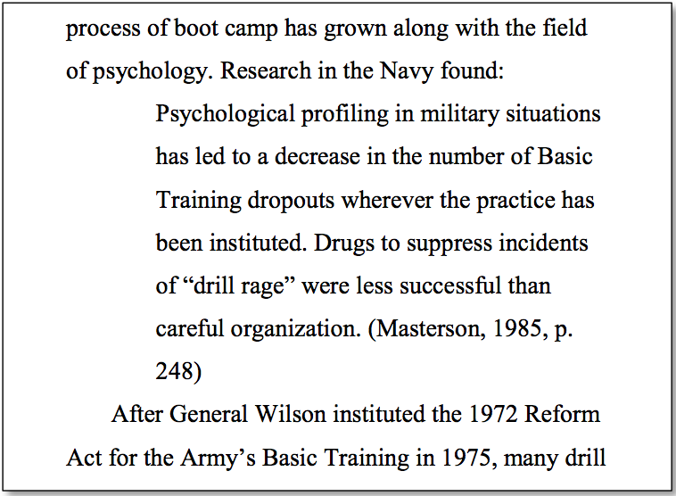
Direct quotations that are less than 40 words should be incorporated into the text, surrounded by quotation marks, and cited. Quotations that are more than 40 words should be placed in a block quote without quotation marks around it. The parenthetical citation for block quotes should always go outside of the ending punctuation. See example at right.
It is important to introduce sources that you are summarizing, paraphrasing, or quoting. When you introduce a source with the author’s name and/or the date, this information does not need to be repeated in the parenthetical citation at the end. Introducing sources in this way is called signal phrasing.
When using signal phrases, always remember that what is not signaled at the beginning of the sentence must be cited in parentheses at the end.
Examples of in-text citations for various signals:
Limited signal, everything in citation
. . . end of paraphrased or summarized sentence, in which you convey the author's ideas in your own words (Krepp, 1985, p. 103).
" . . . end of quoted sentence" (Krepp, 1985, p. 103).
Author and year in signal, page in citation
In 1985, Krepp reported that . . . (p. 103).
Krepp (1985) tells us that . . . (p. 103).
According to Krepp (1985), ". . ." (p. 103).
Multiple works signaled (list alphabetically)
Studies (Jones, 1966; Krepp, 1985; Smith, 1973) have shown that . . .
No author
. . . ("Stocks Lose Again," 1991, p. B16).
According to the news article “Stocks Lose Again” (1991), . . . (p. B16).
To help the reader find the citation on the reference page, start your in-text citation with whatever comes first on the reference page. This is usually the author’s last name, but it can be the first part of the title if there is no author. If the title is the name of the article, put it in quotes; if the title is the name of a book, put it in italics. Add the year of publication so that the reader will know how current the information is.
(Richards, 2008)
(“How to improve your writing,” 2009)
(The Merriam-Webster Collegiate Dictionary, 2002, p. 484)
Page 177 of the APA Publication Manual provides a clear table for producing different types of in-text citations.
Organizing Information
APA style has specific recommendations for creating levels of heading. Generally, papers shorter than 5 pages will not require any headings; constructing paragraphs with topic sentences at the beginning and transitions at the end will serve to label and organize ideas. Headings exist to separate sections of the paper, not to label individual ideas, so headings should only be used when very large sections need to be separated. If your professor has specific headings that he/she wants to see in your paper, follow those recommendations. Do not use numbers, letters, or roman numerals with your headings.
For medium-length papers that only need to be broken up into 3 or 4 sections, use only the first level of heading. When those sections need to be broken up into smaller subdivisions, use the second level of heading. When those second-level sections are still long enough to require further organization, use the third level of heading, and so on.
Methods
Sample and Participant Selection
Assessment and Measures
Q-sort measures.
Life history calendar.
Results
Outcome of Inhibited Children
Personality and self-esteem.
Social network.
Life history and IQ.
Outcome of Aggressive Children
Discussion
Inhibited Children: Delayed Social Transitions
Conclusions and Future Prospects

Level of heading | Format
1 | Centered, Boldface, Capitalized
2 | Flush Left, Boldface, Capitalized
3 | Indented, boldface, lowercase paragraph heading ending with a period.
4 | Indented, boldface, italicized, lowercase paragraph heading ending with a period.
5 | Indented, italicized, lowercase paragraph heading ending with period.
Only very rarely will more than the first two or three levels of heading be necessary. At above right is an example of how the levels of heading can be used. Each heading should have a substantial quantity of text under it. Also, do not create subheadings if that subheading is the only one at its level.
The introduction will be the first section of your paper. Sometimes, an introduction header is not used; rather, it is assumed. Check with your professor to see if headings such as these are necessary.
exception. The following steps are usually taken during the first few days of Marine Corps basic training (called Recruit Receiving):
1. The “jarhead” Marine haircut is given to all the recruits.
2. Uniforms and other items are issued.
3. Recruits memorize the basic rules of boot camp.
4. Lessons in drill and camp structure begin immediately.

Numbering and bulleting of lists can help organize groups of ideas in your paper. It is important that these lists maintain parallel structure, meaning that they need to follow the same grammar, syntax, and concept. Use ordinary numerals with a period following (see example at right).
Only use a numbered list when the order of the material has some significance (importance, usefulness, or chronology). For lists that can be presented in any order, use bullets. Bullets can be small squares, circles, arrows, or anything else. Remember, however, that academic writing should be professional; gaudy icons as bullets will likely distract readers.
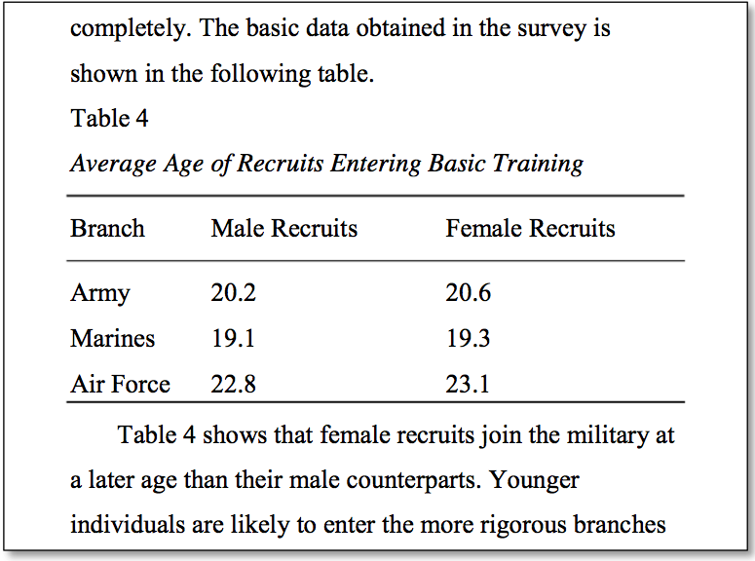
Whenever a large quantity of information needs to be displayed, you can use a table to organize and present it. The table needs to have a numerical label (Table 1 or Table C or Table IV), a title (this should usually be italicized), and horizontal lines around the headings and at the base of the table. You can use Microsoft Word’s Insert > Table function to create these, or you can use paragraph formatting to insert the horizontal lines where you need them. A basic table with simple data presentation is shown below.
Explanation of tables in your text is important so that the reader will understand their relevancy. Always reiterate the most important parts of the data and explain how they are related to your main arguments.
More complex tables can be made by using additional spanning lines to show different groups of data or a row of totals or averages. For very large tables, you can use boldface to highlight the most important points in the data. It may also be necessary to add a short note underneath the bottom span line for definitions.
Contributors
This APA style guide was revised in January 2013 by Cayla Buttram to assure correctness, readability, and cohesion; it was originally created in June 2011 for the University of North Alabama Library and Center for Writing Excellence by David MacMillan III as part of the Library’s libguide redesign program. Additionally, Amber Huett, Dr. Robert Koch, Jr., Katie Sanders, Ash Taylor Crum contributed to the contents and design of this guide.

The four sentences in this short paragraph introduce the topic/problem, present the research question, explain the types of research done, and relate the intended results. Further summary is not necessary.

Ask your professor whether an abstract is required. Not all papers will need one.

LETTING GO 2
Abstract
Boot camps are designed to provide recruits with a sense of group solidarity and identity within the military brotherhood. This project attempted to determine what theories for the adoption of new social constructs are modeled by this training. Research for this project was conducted using interviews with the university ROTC and searches of prior studies in the nursing research databases. This paper identifies the most common psychological systems used in boot camps.

Most undergraduate papers will not require an author note, but it is a good place for any additional information the title page might need. Ask your instructor.

For more than two authors, separate their names with commas and add “and” at the end. “John Smith, Paul Jones, and Ron Mack.”

Use “Different First Page” to make this alternate header. The title page is page 1.

Running head: LETTING GO 1

Letting Go: How Boot Camp
Conditions Soldiers to Leave Their Homes
Jane P. Jones and Robert R. Smith
University of North Alabama

Author Note
This research project was completed in March 2011 with the help of Dr. Jane Bruce in the Nursing Department during NU 453.
Thanks to the ROTC at the university for help in conducting interviews and collecting data.

Chapter in a book.

Article in a journal.

For two to seven authors, separate with commas and finish with the & symbol.

When citing an online source or journal, list the doi or the URL.

If an article has eight or more authors, list the names of the first six authors followed by ... and then the last author's name in the reference entry.
LETTING GO 12
References
Koch, R. (2007). Pocket guide to Boot Camps (2nd ed.). Boston: Houghton Mifflin.
Smith, M., Flanagan, F., Judd, A., Burstyn, E., Bullock, S., Knight, S., … Jones, E.B. (2002). Building connections through team projects. Military Exchange Quarterly, 10(3), 208-213.
Stewart, T., & Biffle, G. (1999). Relationships in social dynamics. Psychiatric psychology: Contemporary practice (pp.124-138). Philadelphia: Lippincott- Williams and Wilkins.
Voltmeijer, I. A. (2000). A Buddhist response to the nature of human rights. Journal of Buddhist Ethics, 8(4). doi:10.1000/182
Whitmeyer, J.M. (2000). Power through appointment [Electronic version]. Social Science Research, 29, 535- 555. Retrieved from http://www.ssresearch.com/articles/04153873453
Double space all text in APA; use a hanging indent on the References page to show paragraphs.

The abstract page, the first body page, and all subsequent pages have the same header.

The title should be centered at the top of the first body page.

LETTING GO 3

Letting Go: How Boot Camp Conditions
Soldiers to Leave Their Homes
For many soldiers, the most memorable aspect of their training was boot camp. Boot camp is the transitional period wherein troops learn to identify with their branch of the armed forces. The process of boot camp has grown along with the field of psychology, and so a comparison between boot camp methods and psychological methods poses an interesting series of questions.
The 1972 Boot Camp Reform Act (Thompson, 2008) instituted a series of changes to the way that the various branches of the military conducted Basic Training. In
References
American Psychological Association. (2001). Publication manual of the American Psychological Association (5th ed.). Washington D.C.: American Psychological Association.
APA formatting and style guide – The OWL at Purdue. (2007). Purdue University Online Writing Lab. Retrieved from http://owl.english.purdue.edu/owl/resource/560/01/
Documenting sources at SNHU: APA style. (n.d.). Southern New Hampshire University. Retrieved from http://acadweb.snhu.edu/documenting_sources/apa.htm#Use%20a%20citation%20when%20you%20paraphrase
Homepage: APA style. (2007). American Psychological Association. Retrieved from http://apastyle.apa.org
Perrin, R. (2007). Pocket guide to APA style (2nd ed.). Boston: Houghton Mifflin.
Quoting, paraphrasing, and summarizing. (2004). Purdue University Online Writing Lab. Retrieved from http://owl.english.purdue.edu/handouts/research/r_quotprsum.html

